EARSWICK PARISH COUNCIL
Minutes of the meeting of Earswick Parish Council, held in Earswick Village Hall on Monday 3rd October 2022.
Councillors present: D Jones
G Offler
P Leveson
BS Wiseman
A Bell

Members of public present: 1

- Apologies for absence
Cllr Dowsett, Ward Cllr Fisher
- Declarations of Interest and Any Other Declarations
None.
- Minutes of Previous Meetings
The minutes of the Parish Council Meeting held on the 11th July 2022, were approved as accurate records by the Councillors and signed.
- Ward Councillors’ Reports

Ward Cllr Doughty gave a brief report:
- A decision has been made for the fire station to be manned by a standby crew
- CYC are about to submit a planning application for the dualling of the A1237
- CYC are due to discuss devolution on Thursday 6th October

Ward Cllr Fisher had sent an email informing the Parish Council that he had done a survey of the street lights in Earswick and informed CYC of the faulty ones.

- Clerk’s Finance Report & Authorisation Of Expenditure

The following pre-authorised payments (incl VAT where appropriate) have been made from the Barclays bank account since the Parish Council (PC) meeting on 11th July 2022:-
- Clerk’s salary for July, August & September 2022
- Clerk’s salary increase backdated to February
- For Village Hall cleaning: £130 (July), £230 (August) and £240 September
- British Gas payments for the Village Hall - £38.81, £11.84 & £19.82
- E-on Next payments for the Village Hall - £30.86, £65.21 & £47.29
- Public Open Space maintenance – July £1,416, August £1,500 and September £1,680
- Hunt Catch Kill - £120
- Advanced Fire Services – quarterly inspection - £55.50
- Scottish Water – Field tap £7.46
- Scottish Water – Village Hall use - £49.68
The various RBS bank accounts have now been closed & the Nat West has no money in it and a request to close it is being processed. This resulted in internal transfers totalling £3.272.14 into the Barclays account.
The following amounts have been received by the PC into the Barclays and RBS accounts since reported at the meeting on 11th July 2022:
- Precept from CYC - £13,171
- £1,833.50 VH Bookings
- £120 in tennis membership fees;
- Interest from Cambridge & County Accounts - £270.79 & £845.09
- Interest on RBS account - approx. £1

- Ratification of Payments

The PC approved the following payments:
- £24.52 - reimburse Clerk for postage
- £30 - reimburse Cllr Leveson for payment to temporary Village Hall cleaner
- £70 – Laurel Bank locksmith – repair to Village Hall key safe
- £390 – J&G Durrant – varnishing of Community Garden benches
- £126 – Reynolds Plumbing – repair of Village Hall boiler
- £460 – Steel & Maw - dealing with diseased trees near Village Hall
- £66.80 – YLCA training for Cllr Dowsett
- £500 – J&G Durrant – varnishing arbours in community garden
- £34 - reimburse Cllr Leveson for cutting of spare Village Hall keys
- £16 - reimburse Cllr Offler for cutting of spare Community Garden keys

- Planning Applications
The Clerk used delegated powers to record no objections from the Parish Council on the following planning application:
- 22/01770/FUL 116 Strensall Road – Two storey side extension with balcony to rear
The following planning applications were approved by City of York Council:
- 22/01117/FUL 76 Earswick Chase Earswick York YO32 9FY Conversion and extension of store room and home office.
- 22/01002/FUL 2 Garden Village, Earswick YO32 9TP (Single storey entrance porch to front of house).
- 22/01158/FUL 354 Strensall Road, YO32 9SW – variation of planning permission 18/01789/FUL.
- Non-material amendment to 21/00194/FUL – plot on Shilton Garth
And to discuss and agree actions related to
- 22/01586/FUL The Granary Foss Bank Farm Strensall Road York YO32 9SW Single storey rear extension. This was discussed and the Parish council objected to it for the following reasons:
  - Previous applications on this green belt site were withdrawn. Officers objected to the scale of the development and one of the reasons the final application in 2018 was approved was because the overall footprint and scale were a reduction on previous applications.
  - An extension on this scale would not be appropriate on a green belt site.
- Concern was expressed that there may be a person living in unsanitary conditions at the site near 114/6 Strensall Road. The clerk to write to CYC on the matter. Action BOC
- Potential planning enforcement associated with 258 Strensall Road – a letter was received on 18th August from CYC stating that conversion to an HMO would classed as permitted development. However, a planning application is still required for converting the property into 2 separate dwellings. The Clerk was asked to write to CYC to ask for the status of this application as it should have been submitted by 29th August. Action BOC

- Monthly Equipment Check

A check was carried out by Cllr Offler and a report circulated prior to the meeting. No H&S action needed on playground but VH sink outlet is being blocked by gravel. G&J Durrant to be asked for a quote to install a drain cover. Action Cllrs Offler/Leveson

We have received a ROSPA report on safety but there was nothing urgent or high priority to do. Cllr Offler was asked to address the ones she could and seek authorisation for those that needed money spending. Cllr Offler

- Work to cut back vegetation in and around the pond, and to plant oxygenating plants.

The matter was discussed and it was agreed that we would spend £300 + VAT on work to cut back vegetation in and around the pond, and a further £240 + VAT to plant oxygenating plants in the pond. Cllr Offler to liaise with Mr Dent of St Nicks to arrange for the work to be done. Cllr Offler

- 20 mph Speed Limit Along The Village Street

The matter was discussed and it was agreed that we should write to CYC to request information about their conditions/criteria for implementation of such zones. Action BOC

- Tender Documents For Maintenance Of Public Open Space

The 3 quotes received were discussed and it was agreed that we would accept the quote from Mr A Hill at a total cost of £12,312 p.a. i.e. £10,260 excl VAT for 3 years. The clerk was asked to write to Mr Hill to confirm this and to amend contract. Action BOC

- Budget / Precept For 2023-4

The budget and precept for 2023-4 were discussed and it was agreed that we would apply for an increase in the precept by 5% i.e. from £27,132.76 to £28.489.30. Action BOC

It was also agreed that we would increase the Village Hall hiring fees by £1 per hour as of 1st April 2023.

- Cover For Village Hall Central Heating Thermostat

The matter was discussed and it was agreed that we would reimburse Cllr Wiseman £15.75 for the cover & pay J&G Durrant £20 for its fitting. Action BOC

- Emergency Item – Costs To Make Safe 3 Trees In Garden Village

The matter was discussed and it was agreed that we would pay Steel & Maw £555 to make safe 3 trees in Garden Village. Action Cllr Offler

- Ratification of decisions

The PC ratified the following decisions:
- To write to CYC about vegetation overhanging the road outside a property on Earswick Chase. The vegetation has now been cut down but there is still confusion as to who has title to the strip of land and is therefore responsible for cutting back the vegetation on it. CYC have been asked to provide a copy of the related search of the land registry.
- To write to resident about encroachment of public open space – most of fence now removed but one piece remains. The clerk to write to owner asking him to remove it. Action BOC
- To write to YLCA to say that Earswick Parish Council do not support their proposal for a Grants Bulletin

- Items for information
Items for information – to include any reports from Councillors attending meetings as representatives of the Parish Council, any updates on Neighbourhood Watch, and items for the next agenda.
- The clerk was asked to write the Neighbourhood Watch Coordinators to see if they have plans to move away from the area and if so who will take over from them. Action BOC
- At the next meeting to discuss how we can help get more volunteers for the Scented Garden

The meeting closed at 8:40 pm.

B O’Connor
Clerk To Earswick Parish Council

=====================================================

NEIGHBOURHOOD WATCH ANNUAL REPORT -SEPTEMBER 2022.
The audit of Earswick Neighbourhood Watch and Cold Calling signs helped to inform where signs were missing, needed cleaning, or replacing. As a result of this it was identified that Earswick has 17 Neighbourhood Watch signs in various places around the village. 10 were identified as being in a good and clean condition. Over the summer we have cleaned those Neighbourhood Watch signs which were dirty and have also replaced three with new signs. With the support of residents a few hedges and trees were trimmed back to make signs more visible. The five Cold Calling signs covering The Village and Earswick Chase areas were also cleaned.
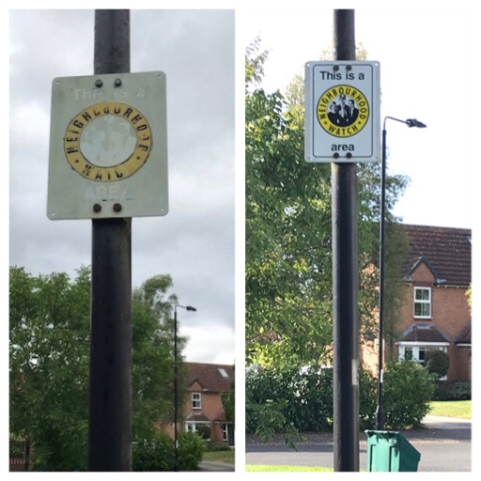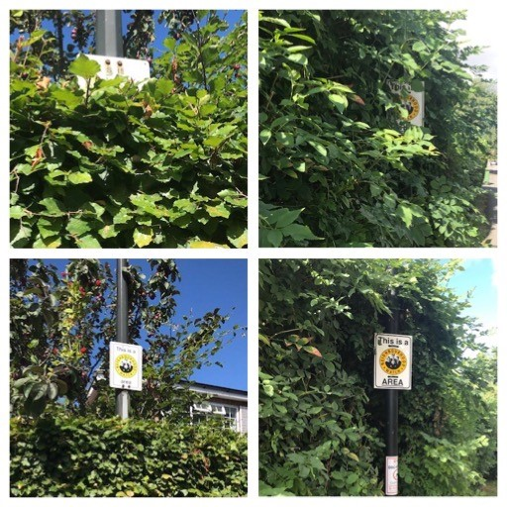
Signs were replaced Hedges were trimmed
Very few issues have been raised with us over the summer.
One resident acted and informed a NW Coordinator of a noise nuisance incident. This involved a group of teenagers who were making their way from the field along Lock House Lane and towards Strensall Road. It was reported that one youth climbed onto a car roof. Details of the new PCSO for Earswick were obtained and circulated to allow reporting of the incident.
Another reported an intruder in their garden. Details were circulated to Coordinators with encouragement for residents report any further incidents to the police. Incident/Crime numbers should be requested at the time of reporting to allow incidents to be connected.
Email, telephone, and text scams continue to be an ongoing nuisance. Residents are encouraged again to report these to Action Fraud on 0300 123 2040 or via their website. Suspicious emails can also be forwarded to report@phishing.gov.uk. and texts to 7726.
Attempts to contact the Community Speed Watch have failed, so no further progress has yet been made with this. We will try again now the holiday period is over. Speeds along Strensall Road through the village do appear to have reduced now drivers have got used to the 40mph limit further along.
Thank you again to the NW Coordinators for their support in circulating and sharing information, helping keep Earswick a safe and happy place to live.
Linda and Tony Murphy,
Earswick NW Scheme Coordinators.

