Mr Julian Sturdy M.P.
1 Ash Street
Poppleton Road
York
YO26 4UR

Dear Julian

Ref: Proposed A1237 York Outer Ring Road Improvements. Roundabout: Strensall;
Plot: SJ1

Earswick Parish Council have been in discussions with CYC and DVS Property Specialists with regard to the proposed changes to the roundabout at the junction of the Strensall road and A1237.

As landowners we have been approached by CYC to purchase this land to enable the alteration to the road layout. If we do not agree to this purchase then a Compulsory Purchase Order will be implemented.

Members of the PC met with the registered Valuer and a Highway Engineer from CYC to discuss the extent of the land involved. The PC have also hired James Stephenson (as suggested) to act on their behalf during the negotiations.

Whilst the Engineer indicated that the draft plans shown to us were not necessarily the final drawings, we were most concerned that CYC do not appear to be considering an underpass on both sides of the road. The plans indicate an underpass from the row of cottages on the west side of the Strensall Road going beneath the A1237 and joining Abbot’s Gait in Huntington. This would be of benefit to pedestrians and cyclists travelling northwards to Earswick/Strensall, but of no use for the pedestrians and cyclists who wish to travel southwards from Earswick/Strensall.

There are approximately 14 school buses, which travel this route to school daily, and many children who live in Earswick and further north would like to cycle, but this junction, at present, is potentially hazardous. Having an underpass would be welcomed, but on one side only would not serve any solution to this busy crossing.

I am writing to ask for your support and help with redesigning this junction before costs are incurred, to include another underpass on the Eastern side of this junction. CYC have indicated that the alterations would need Planning Permission and possibly be started in 2021.

The Parish Council feel that the design of this junction should be urgently looked at again with a view to including underpasses on both sides of the Strensall road.

Kind Regards

Sincerely.

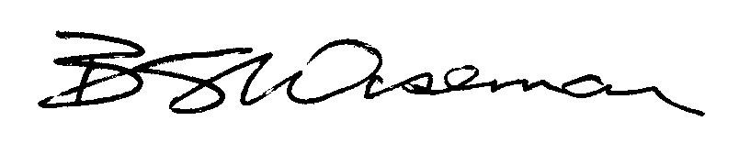

Vice Chair
Earswick Parish Council

