From: Farnham, Melanie <Melanie.Farnham@york.gov.uk>
To: Parish Council Earswick <earswickclerk@aol.com>
CC: Frost, Gary <Gary.Frost@york.gov.uk>
Sent: Wed, 1 Dec 2021 16:20
Subject: RE: Earswick Parish Council's concerns regarding the proposed A1237 development
Hi again Joanne

Just to clarify, the proposed crossing of Strensall Road is actually in technical terms called a “Parallel” crossing, which adopts the principles of a zebra crossing for both pedestrians and cyclists. The proposed parallel crossing of Strensall Road would be something similar to below ….

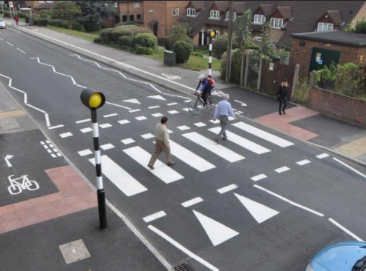

Hope this is of assistance

Kind regards
Melanie

Melanie Farnham | Senior Project Manager - Major Transport Projects
m: 07879 808313 | e: melanie.farnham@york.gov.uk

City of York Council | Directorate of Place
West Offices | Station Rise | York | YO1 6GA
www.york.gov.uk | facebook.com/cityofyork | @CityofYork

From: Farnham, Melanie
Sent: 01 December 2021 16:09
To: Parish Council Earswick <earswickclerk@aol.com>
Cc: Frost, Gary <Gary.Frost@york.gov.uk>
Subject: RE: Earswick Parish Council's concerns regarding the proposed A1237 development

Dear Joanne

Further to your correspondence with Cllrs in the e-mail dated the 3rd November 2021, please see attached the YORR project team’s response regarding the re-location of the proposed zebra crossing on Strensall Road.

As mentioned in the attached letter, I draw your attention to the request for confidentiality with regards to the attached drawing as this may be subject to change.

I trust that this information is helpful. Should you have any further queries please let me know.

Kind regards
Melanie

Melanie Farnham | Senior Project Manager - Major Transport Projects
m: 07879 808313 | e: melanie.farnham@york.gov.uk

City of York Council | Directorate of Place
West Offices | Station Rise | York | YO1 6GA
www.york.gov.uk | facebook.com/cityofyork | @CityofYork

From: earswickclerk@aol.com <earswickclerk@aol.com>
Sent: 03 November 2021 20:09
To: Cllr. K. Aspden <cllr.kaspden@york.gov.uk>; Cllr. A. D'Agorne <cllr.adagorne@york.gov.uk>
Cc: Cllr. N. Ayre <cllr.nayre@york.gov.uk>; Cllr. D. Craghill <Cllr.dcraghill@york.gov.uk>; Cllr. I. Cuthbertson <cllr.icuthbertson@york.gov.uk>; Cllr. C. Runciman <cllr.crunciman@york.gov.uk>; Cllr. D. Smalley <cllr.dsmalley@york.gov.uk>; Cllr. A. Waller <cllr.awaller@york.gov.uk>; Cllr. P. Widdowson <cllr.pwiddowson@york.gov.uk>; Cllr. P. Doughty <cllr.pdoughty@york.gov.uk>; tonythekingfisher@btinternet.com; Frost, Gary <Gary.Frost@york.gov.uk>; Farnham, Melanie <Melanie.Farnham@york.gov.uk>
Subject: Earswick Parish Council's concerns regarding the proposed A1237 development

This email originated from outside of the organisation. Do not click links or open attachments unless you recognise the sender and know the content is safe.
Dear Cllrs Aspden and D'Agorne

Please would you see the attached letter from Earswick Parish Council.

Kind regards

Joanne Fisher
Clerk to Earswick Parish Council
* * * * * * * * * * * * * * * * * * * * * * * * * * * * * * * * * * * * * * * * * * * * * *
Help protect the environment! - please don't print this email unless you really need to.
* * * * * * * * * * * * * * * * * * * * * * * * * * * * * * * * * * * * * * * * * * * * *
This communication is from City of York Council.
The information contained within, and in any attachment(s), is confidential and legally privileged. It is for the exclusive use of the intended recipient(s). If you are not the intended recipient(s), please note that any form of distribution, copying or use of this communication, or the information within, is strictly prohibited and may be unlawful. Equally, you must not disclose all, or part, of its contents to any other person.
If you have received this communication in error, please return it immediately to the sender, then delete and destroy any copies of it.
City of York Council disclaims any liability for action taken in reliance on the content of this communication.
City of York Council respects your privacy. For more information on how we use your personal data, please visit https://www.york.gov.uk/privacy

